Cutter Toolz for Corel Draw
I’m not a Code writer much of this was created using AI
Two CorelDRAW VBA macros — Quik Cutz and Snake Cutz — for turning a single sticker/cut shape into a full sheet layout automatically, plus a workspace file that adds toolbar buttons for both. Ported from the “Quik Cutz” and “Snake Cutz” Inkscape 1.x extensions.

What’s in this repo
File | Description
Cutter_Toolz.cdws | CorelDRAW workspace — adds a toolbar with buttons that run both macros
QuikCutz.gms | Quik Cutz macro project (grid cutting tool)
SnakeCutz.gms | Snake Cutz macro project (chained circle/ellipse cutting tool)

Installation

Option 1: Import the Workspace file (.cdws) — easiest
Installs everything, including the toolbar buttons, in one step.
- Open CorelDRAW.
- Go to Tools > Customization (or Tools > Options, depending on version).
- Click Workspace in the left-hand tree (the top-level item).
- Click Import/Export… at the bottom of the dialog.
- Choose Import a workspace from file, browse to Cutter_Toolz.cdws, and select it.
- Follow the wizard, make sure everything (toolbars, commands, macros) is checked, then Finish.
- Restart CorelDRAW when prompted.
- If the toolbar isn’t visible, enable it via Window > Toolbars > Cutter Toolz.

Option 2: Install the .gms macro files manually
Copy the .gms files into CorelDRAW’s macro (GMS) folder. There are two valid locations depending on your setup — use whichever one already has other .gms files in it, or create the folder if it doesn’t exist yet.
Option A — Program Files (all users):
C:\Program Files\Corel\CorelDRAW <YourVersion>\Draw\GMS\en\
Option B — AppData Roaming (current user only):
C:\Users\<YourUsername>\AppData\Roaming\Corel\CorelDRAW <YourVersion>\Draw\GMS\en\
Steps: 1. Close CorelDRAW if it’s open. 2. Copy QuikCutz.gms and SnakeCutz.gms into one of the folders above (replace <YourVersion> and <YourUsername> with your actual CorelDRAW version and Windows username). 3. Open CorelDRAW. 4. Go to Tools > Macros > Manage Macros (or press Alt+F11 to open the VBA editor and confirm the projects loaded). 5. The QuikCutz and SnakeCutz projects should now appear in the macro list. 6. Run a macro via Tools > Macros > Run Macro, or assign it to a toolbar button/keyboard shortcut for quicker access.

Plugin Overview

Quik Cutz — grid layout from a single sticker
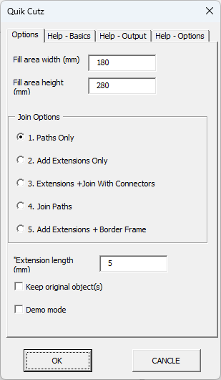
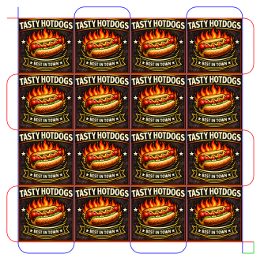
Select one native rectangle (the cut line) plus, optionally, any artwork you want repeated with it (image, text, group), then run the macro.
- Fill Area sizing — you enter a target width/height in mm; the number of columns and rows is worked out automatically from the cut shape’s own size (no need to count copies yourself).
- Build direction is fixed — the grid always builds right and down from your original selection, which stays put as the top-left cell.
- Stub / Join Options — one 5-way choice controls how the cut lines are finished:
  - Plain grid — no stubs, no joins, no border.
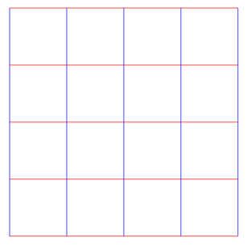
- Stub extensions only — each line overshoots its true end by a set length (default 5 mm), useful for reliable pierce/tie-off points; ends stay unjoined.
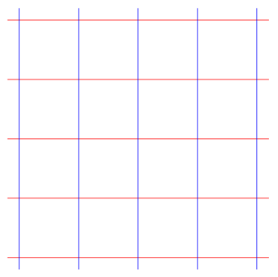
- Stubs + join with connectors — every horizontal divider becomes one continuous path, every vertical divider becomes another, with automatically filleted (rounded) corners at each join.
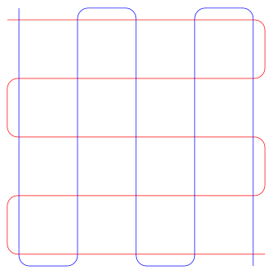
- Stubs + connectors + join both paths — everything in option 3, plus the horizontal and vertical paths are joined into a single path with one sharp corner.
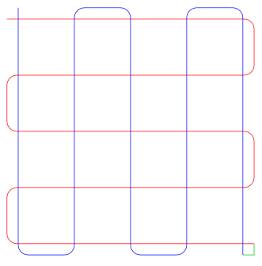
- Stubs + border frame — adds a rectangle traced around the whole grid, in addition to the two cut paths.
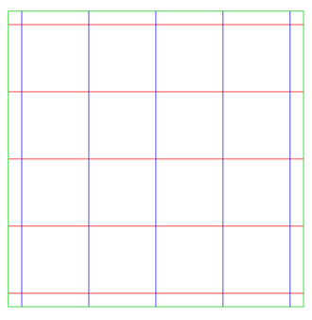
- Keep Original Object(s) — off (default) removes the original cut rectangle and folds your original artwork into the output; on leaves your original selection completely untouched and duplicates fresh copies into every cell.
- Demo/test mode — colors the horizontal path red and vertical path blue so you can sanity-check the layout before cutting.
- Output — cut lines are grouped as QuikCutz (QuikCutz_1, QuikCutz_2, …); duplicated artwork is grouped separately as Images (Image_1, Image_2, …).

Snake Cutz — chained circle/ellipse layout
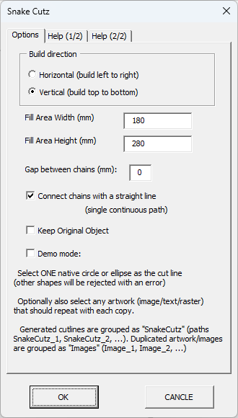
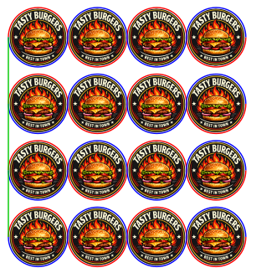
Select one native circle or ellipse (the cut line) plus, optionally, artwork to repeat, then run the macro. Rectangles, stars, or converted paths aren’t accepted — the shape must be a true circle/ellipse.
- Fill Area sizing — same idea as Quik Cutz: give a target width/height in mm and the number of copies per chain, and the number of parallel chains, are calculated automatically.
- Build direction — Horizontal (left to right) or Vertical (top to bottom); each circle sits tangent to the next with no gap.
- Multiple chains — extra parallel chains are added to fill the perpendicular dimension, spaced by the shape’s diameter plus a “Gap between chains” value (mm) that you set.
- Connect chains — on (default) joins every chain into one continuous cut path; off leaves each chain as its own separate closed path.
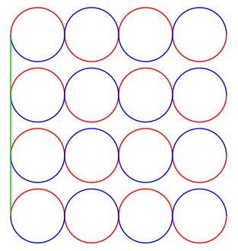
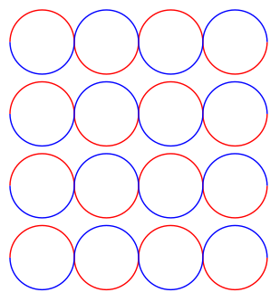
- Keep Original Object(s) — same behavior as Quik Cutz: off folds your original selection into the output, on leaves it untouched.
- Demo/test mode — draws the forward pass in red, return pass in blue, and connectors in green as separate preview paths.
- Output — cut lines are grouped as SnakeCutz (SnakeCutz_1, SnakeCutz_2, …); duplicated artwork is grouped separately as Images (Image_1, Image_2, …).

Cutter_Toolz (workspace)
Not a macro itself — a CorelDRAW workspace file that adds a toolbar with one-click buttons wired to both macros above, so you don’t need to open the Macros menu every time.

Notes
- Both macros are ports of existing Inkscape 1.x Python extensions (quik_cutz_grid.py and snake_cutz.py), rewritten against CorelDRAW’s VBA object model.

